Week 4 Dashboard Build Notes
Project Title: Campus Cultural Fest Operations Dashboard & Process Optimization System
Prepared By: Karthick Raja
Objective
The objective of this phase was to develop an interactive dashboard using Looker Studio to visualize operational data collected during the Campus Cultural Fest.
The dashboard was designed to provide stakeholders with a centralized view of event performance and support data-driven decision-making.
Dashboard Development Approach
The dashboard was developed using data generated and validated during previous project phases.
The following steps was followed:
- Prepared and validated source datasets.
- Identified key performance indicators (KPIs).
- Mapped KPIs to dashboard visualizations.
- Connected datasets to Looker Studio.
- Developed dashboard pages.
- Verified dashboard results against SQL analysis outputs.
Tools Used
Tool | Purpose
Python | Sample data generation
SQLite | Database creation and querying
SQL | Data analysis and KPI calculations
Excel | Data validation and chart preparation
Looker Studio | Dashboard development
VS Code | Development environment

Data Sources
The dashboard was built using the following datasets.
Dataset | Purpose
Events.csv | Event details
Registrations.csv | Registration tracking
Attendance.csv | Attendance tracking
Volunteers.csv | Volunteer information
Task_Assignments.csv | Volunteer task monitoring
Incidents.csv | Incident management
KPI_Dataset.csv | Dashboard KPI metrics

Dashboard Structure
The dashboard consists of five pages.
Page 1 – Executive Summary
Purpose:
Provide a high-level overview of event operations.
KPIs Displayed:
- Total Registrations
- Total Attendance
- Attendance Rate
- Total Volunteers
- Total Incidents
- Average Resolution Time
Outcome:
Stakeholders can quickly understand overall event performance from a single page.
Page 2 – Registration Analysis
Purpose:
Analyze participant registrations across cultural fest events.
Visualizations:
- Registrations by Event
- Event Registration Summary Table
Key Insight:
Event 108 received the highest number of registrations, indicating strong participant interest.
Page 3 – Attendance Analysis
Purpose:
Analyze attendance performance.
Visualizations:
- Attendance Status Distribution
- Attendance Rate KPI
Key Insight:
Attendance rate exceeded the project target of 75%, indicating strong participant engagement.
Page 4 – Volunteer Analysis
Purpose:
Monitor volunteer workload and task completion.
Visualizations:
- Tasks Assigned per Volunteer
- Task Status Distribution
Key Insight:
Volunteer workload was distributed across the organizing team, supporting efficient event operations.
Page 5 – Incident Analysis
Purpose:
Monitor operational incidents and response effectiveness.
Visualizations:
- Incident Type Distribution
- Open vs Closed Incidents
- Priority Distribution
- Average Resolution Time
Key Insight:
Most incidents were operational and technical in nature, with resolution times remaining within acceptable limits.
Key Performance Indicators Included
KPI | Value
Total Registrations | 650
Total Attendance | 499
Attendance Rate | 76.77%
Absentee Rate | 23.23%
Total Volunteers | 20
Total Tasks Assigned | 50
Total Incidents | 40
Open Incidents | 19
Closed Incidents | 21
Average Resolution Time | 34.30 Minutes

Dashboard Testing
Dashboard results were compared against SQL query outputs generated during Week 3 analysis.
The following validations were performed:
Validation Item | Status
Registration Counts Verified | Pass
Attendance Metrics Verified | Pass
Volunteer Metrics Verified | Pass
Incident Metrics Verified | Pass
KPI Dataset Validation Verified | Pass
Challenges Faced
During dashboard development, the following challenges were encountered:
- Preparing datasets in a format compatible with Looker Studio.
- Ensuring KPI calculations matched SQL outputs.
- Organizing visualizations across multiple dashboard pages.
- Maintaining consistency between datasets and dashboard metrics.
These challenges were resolved through data validation and dashboard testing.
Business Value
The dashboard provides stakeholders with:
- Visibility into event registrations.
- Monitoring of attendance performance.
- Tracking of volunteer activities.
- Monitoring of operational incidents.
- Access to key operational KPIs.
The dashboard supports quicker reporting and improved operational decision-making.
Conclusion
The Campus Cultural Fest Operations Dashboard was successfully developed using Looker Studio. The dashboard consolidates registration, attendance, volunteer, and incident management data into a centralized reporting solution.
The completed dashboard provides an effective tool for monitoring event operations and serves as the primary reporting interface for project stakeholders.

Appendix – Dashboard Screenshots

Executive Summary Dashboard:
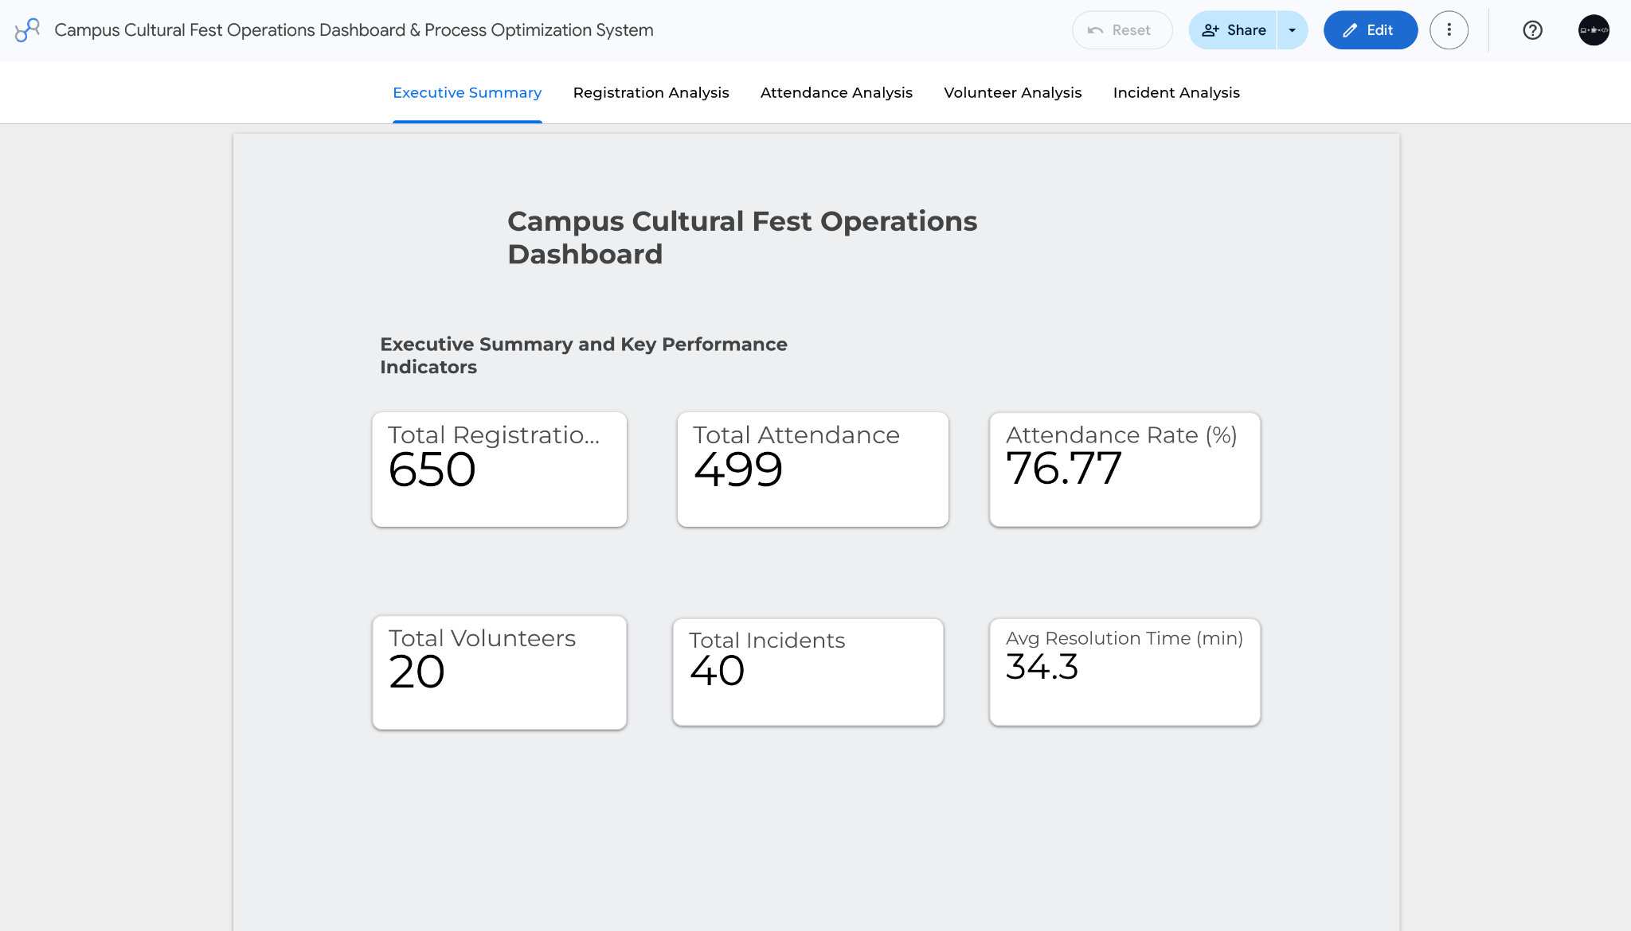

Registration Analysis Dashboard
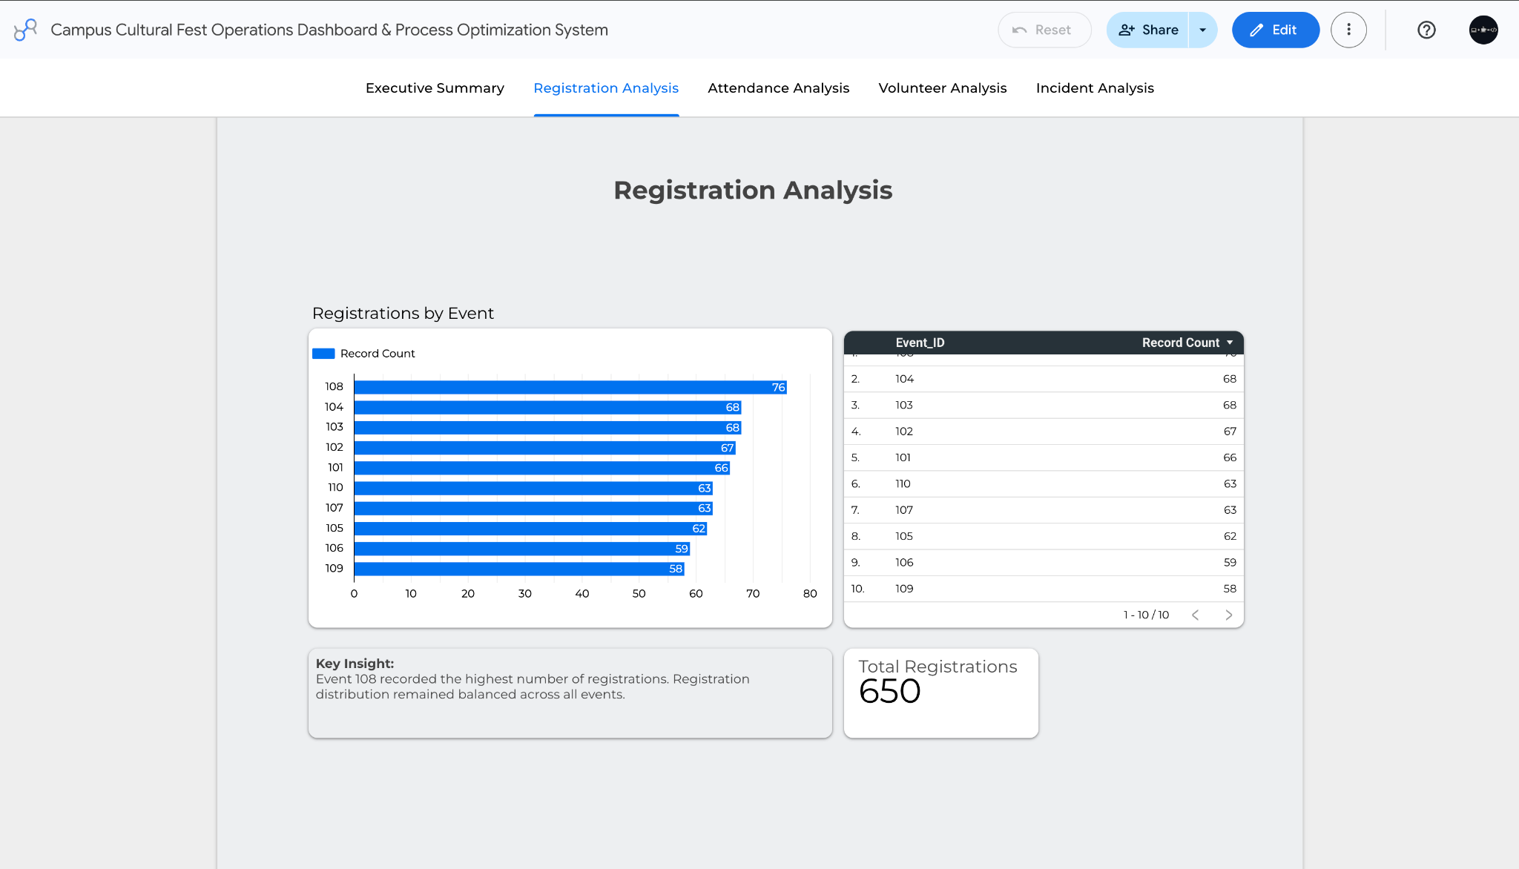

Attendance Analysis Dashboard
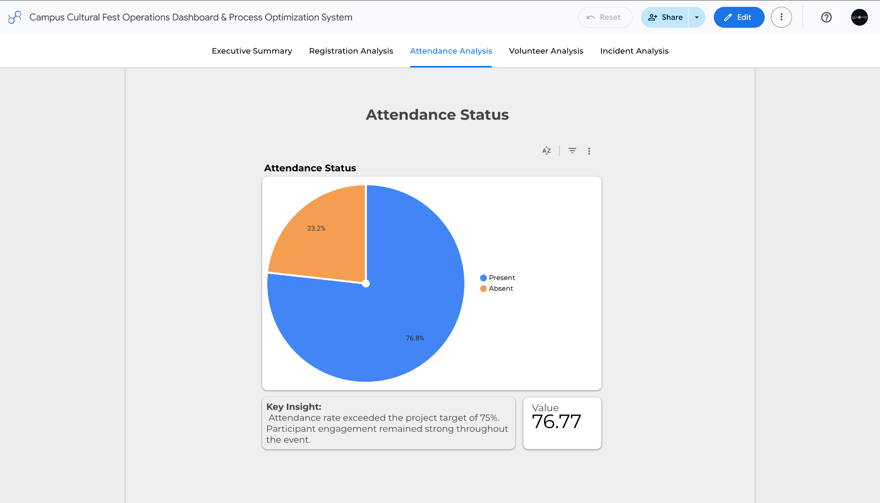

Volunteer Analysis Dashboard
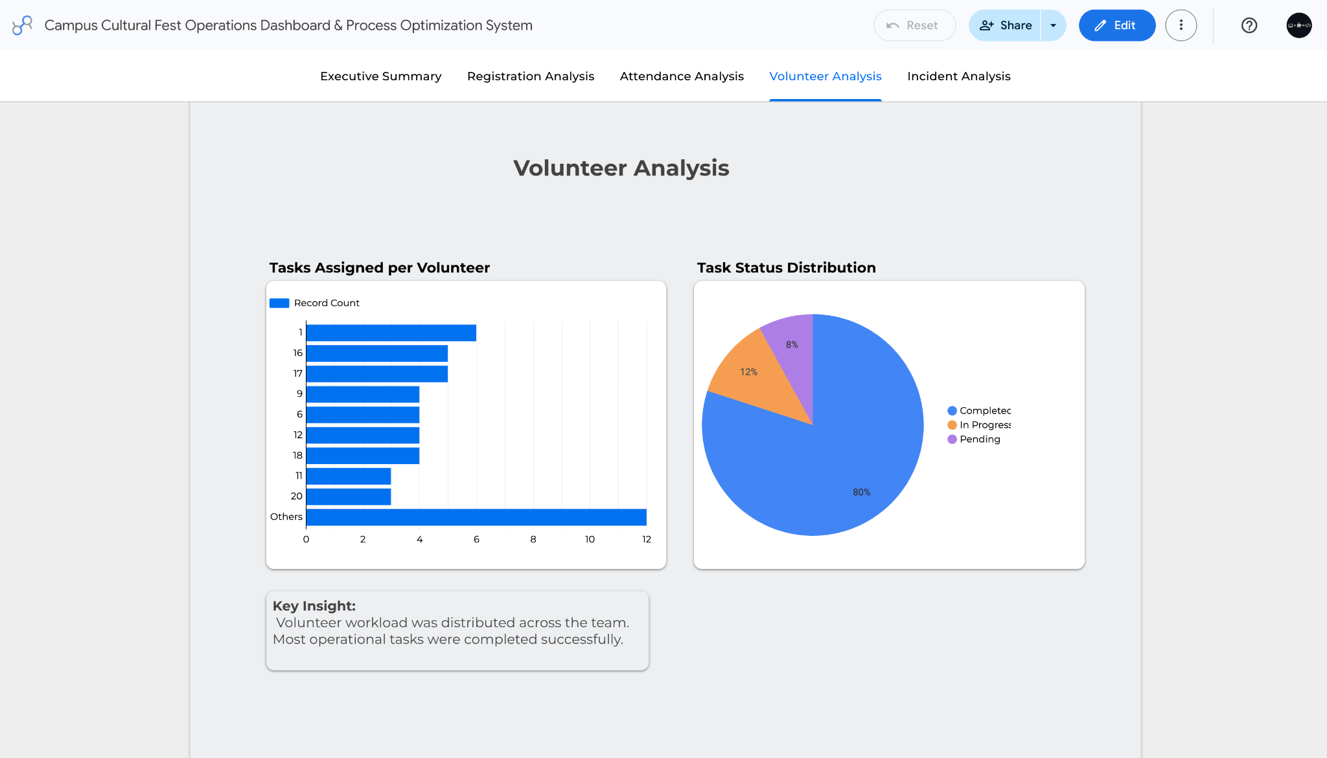

Incident Analysis Dashboard
